CHAPTER 12 | LIGHT INDUSTRIAL DISTRICT (LI)

SECTION 12.10 INTENT

INTENT

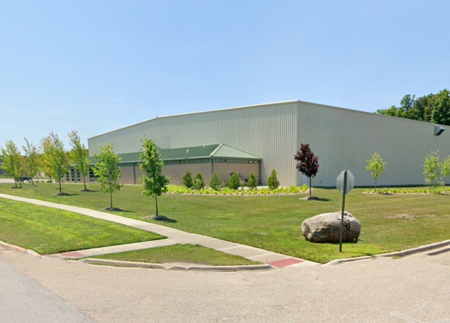
This zoning district is intended for lighter manufacturing, as well as heavier commercial uses and support services. Sites in this zoning district should have ready access to necessary utilities and direct access to major truck transportation routes with significant separation and buffering from residential areas. Characteristics of uses and land in LI may include outdoor storage areas, truck traffic, manufacturing, large buildings, and multiple worker shifts.

PURPOSE

This section includes the dimensional requirements for lots and the requirements for the location and size of principal and accessory buildings and structures.

SECTION 12.20 REQUIREMENTS

LAND USE

See Chapter 15 for all land use regulations and requirements. Further restrictions may apply.

BUILDING REQUIREMENTS

See Chapter 16 for all building requirements.

DIMENSIONAL REQUIREMENTS: ALL BUILDINGS

Lots. All lots shall meet the minimum area, dimensional, and width requirements of Table 12.20 C. Lots shall not be created or changed in size or dimension except in conformance with these requirements.

Buildings. All placement of buildings shall conform to the minimum dimensional and sizing requirements listed in Table 12.20 C.

Accessory Buildings. See Section 18.20.

TABLE 12.20 C: LI DISTRICT DIMENSIONAL REQUIREMENTS
Lot Requirements
Min. Lot Area (see Section 3.30 D) |  |  |  | 1 acre
Min. Lot Width (see Section 3.30 D) |  |  |  | 150 ft.
All Buildings
Max. Building and Structure Height (see Section 3.20 A & C) |  | Under 100 ft. from property lines |  | 35 ft.
 |  | 100 ft. or more from property lines |  | 60 ft.
Min. Setbacks (see Section 3.40) | Front and Street Side |  | County Primary Street | 100 ft.
Min. Setbacks (see Section 3.40) |  |  | Local Street | 50 ft.
Min. Setbacks (see Section 3.40) | Side adjacent to a non-residential district |  |  | 15 ft.
Min. Setbacks (see Section 3.40) | Side adjacent to a residential district |  |  | 50 ft.
Min. Setbacks (see Section 3.40) | Rear adjacent to a non-residential district |  |  | 25 ft.
Min. Setbacks (see Section 3.40) | Rear adjacent to a residential district |  |  | 50 ft.

